**Critical Play Report – *Street Fighter***

Composer: Gordon (Cunbo Li)

Email: [gordon.lee@nyu.edu](mailto:gordon.lee@nyu.edu) or [cl3846@nyu.edu](mailto:cl3846@nyu.edu)

*Street Fighter* is one of the most popular fighting game in current video game market. I love *Street Fighter* very much, not only because of it is entertaining but also because mastering special skill and move of character in *Street Fighter* is very interesting.

*Street Fighter* has 16 basic characters and special characters (depend on versions or stories). Each character has his or her own skills and special movement to win a fight. If the player only traits this game as an entertainment, *Street Fighter* is not a hard game to play. The player can have fun by going through the story mode. However, to improve your skills or master each character, the player should learn their personalities and skills. Remembering button combination and sequences is the most efficient way to getting familiar with each character, and, of course, spending time on training.

There are several common movements for every character in Street Fight. In my point of view, getting familiar common movement is the start point for training. Because these movements are easy to trigger and the player can practice how to press buttons in the same and how to press buttons following a certain sequent. For example, V-Skill, which means using a character’s special movements and abilities, triggered by pressing Medium Punch and Medium Kick at the same time. V-Trigger, by pressing Hard Punch and Hard Kick. And, Throw your opponent by pressing Light Punch and Light Kick at the same time when you close to your opponent. When the player getting familiar with pressing buttons simultaneously and sequentially, it is time to move forward to character’s special movement training. Ryu (Showing in Figure01) is a good choice for start. Because he is strong, powerful and fast. The most famous special moves for Ryu is Hadoken by quarter rotate left stick from the bottom and then press Punch quickly. Ryu will throw out a fireball. The player cannot press this button sequent too slow or too fast. So practicing timing in button sequent is really important. Then, Shoryuken, with buttons of Left stick forward and backward and then Punch. Ryu can punch the opponent forward to the sky and gives him or her powerful damage. And, Tatsumaki Senpukyaku, with buttons of quarter rotate Left stick in the counter direction from the bottom and then press Kick. Ryu will give his opponent a spiraling tornado kick, which is a very strong attack. With familiar of Ryu, the player can either keep mastering Ryu or change to another preferred character.

Figure01

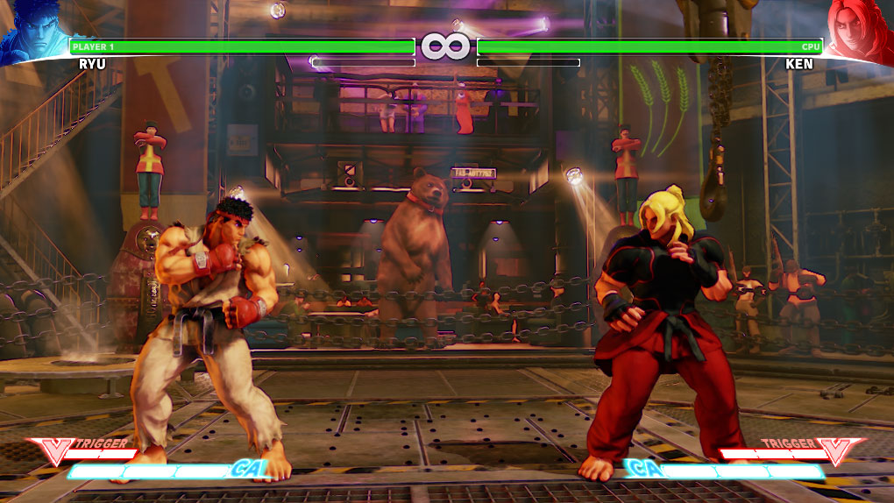

I also trained Chun-Li (Showing in Figure02) as the next character. Chun-Li is one of the female roles in the game. She is not as strong as a male character but she is fast, agility and smart. Her advantages will totally recover his weakness if the player knew how to reasonably use Chun-Li’s unique attacks and special moves with better training. For example, special moves like Kikoken, triggered by moving left stick back and then forward and then press Punch, but normal Kikoken has limited range and cannot reach to the opponent if out of the distance. In order to recover Chun-Li’s shortage, the player can trigger EX-Kikoken by pressing Light Punch and Middle Punch simultaneously. Ex-Kikoken is powerful enough to attack without range limitation.

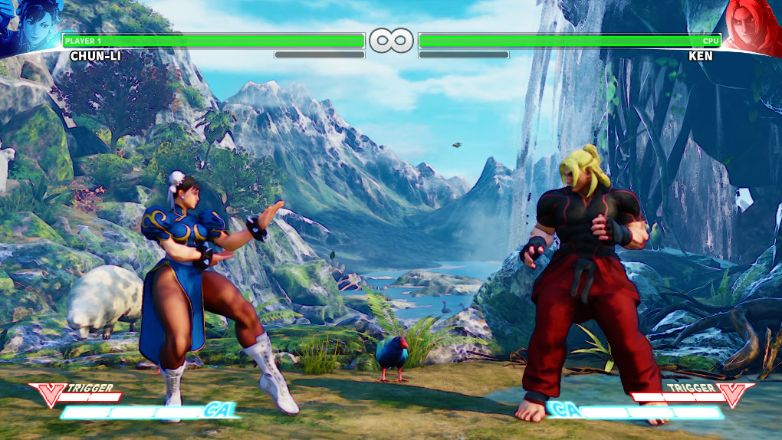

Figure02

In summary based on the above discussion, I believe that the most interesting part of Street Fight is not going through the story mode or enjoying this game as an entertainment, but the processing of mastering every character or the character the player interests in. If the player masters his or her player very well and understands using special moves reasonably, it is a time to compete with other players and enjoy the final victory of the fight.